# Practical-1

**Name of Experiment: To design all logic gate with help of Logisim Tools required: Logisim**

**Theory:** Computer architecture is the organisation of the components which make up a computer system. A logic gate is a device that acts as a building block for digital circuits. They perform basic logical functions that are fundamental to digital circuits.

## NOT

**BLOCK DAIGRAM:**

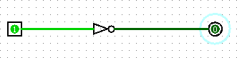

**Result:**

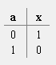

## AND

**BLOCK DAIGRAM:**

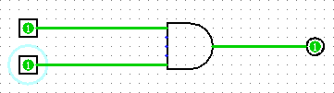

**Result:**

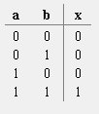

## OR

**BLOCK DAIGRAM:**

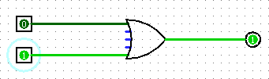

**Result:**

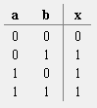

## NAND

**BLOCK DAIGRAM:**

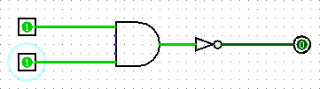

**Result:**

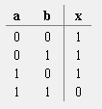

## NOR

**BLOCK DAIGRAM:**

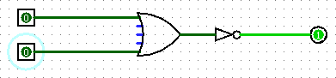

**Result:**

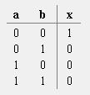

## XOR

**BLOCK DAIGRAM:**

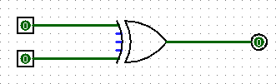

**Result:**

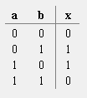

## XNOR

**BLOCK DAIGRAM:**

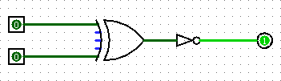

**Result:**

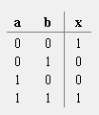

# Practical-2

**Name of Experiment: Design half and full Adder Tools required: Logisim**

**Theory:** The Half Adder is a type of combinational logic circuit that adds two of the 1-bit binary digits. It generates carry and sum of both the inputs. The Full Adder is also a type of combinational logic that adds three of the 1-bit binary digits for performing an addition operation.

**Half Adder**

1. **BLOCK DAIGRAM:**

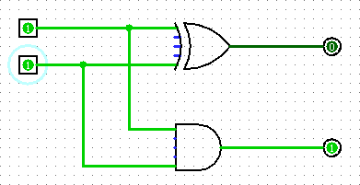

**Result:**

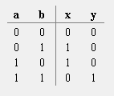

1. **Full Adder**

**BLOCK DAIGRAM:**

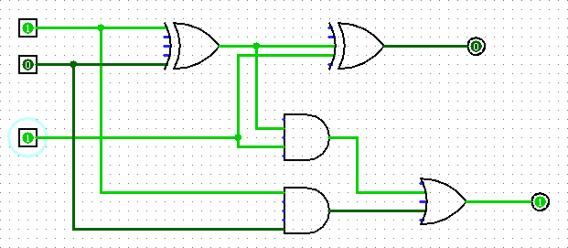

**Result:**

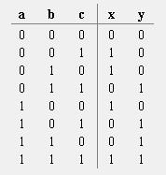

# Practical-3

**AIM: Construct the Logical Diagram for tri state bus buffers and construct CBS system using Logisim**

**Theory:** A tristate buffer can be thought of as a switch. If B is on, the switch is closed.

Tri-state buffers can be implemented using gates, flip-flops, or other digital logic circuits. They are useful for reducing crosstalk and noise on a bus, and for allowing multiple devices to share the same bus without interference.

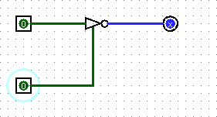

**Result:**

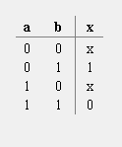

# Practical-4

**AIM: Design the computational circuit for shift register.**

**Theory:** Flip flops can be used to store a single bit of binary data (1 or 0). However, in order to store multiple bits of data, we need multiple flip-flops. N flip flops are to be connected in order to store n bits of data. A Register is a device that is used to store such information. It is a group of flip-flops connected in series used to store multiple bits of data. The information stored within these registers can be transferred with the help of shift registers.

Shift Register is a group of flip flops used to store multiple bits of data. The bits stored in such registers can be made to move within the registers and in/out of the registers by applying clock pulses. An n-bit shift register can be formed by connecting n flip-flops where each flip-flop stores a single bit of data. The registers which will shift the bits to the left are called “Shift left registers”. The registers which will shift the bits to the right are called “Shift right registers”.

